List of Practical
Course: B.Tech CS & IT Semester: VI
Subject: Web Technology Lab Subject Code: [PBC-602, PIT-602]

HTML 5
1. Demonstrate all the text formatting tags in a single HTML page.
2. Write a HTML code to draw the following Figure :
*
* * *
* * * * *
* * * * * * *

3. Create a web page to print the following table:
List of Course-wise Subjects
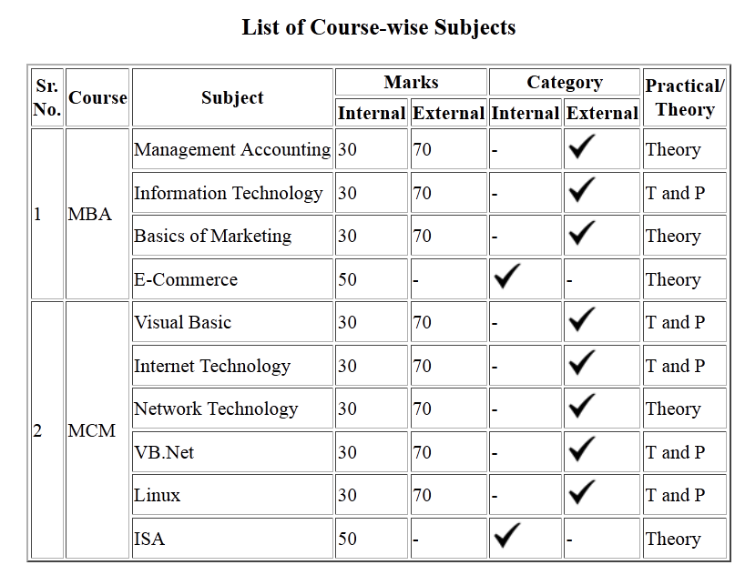
4. Using table related tags align the images with hyperlinks.
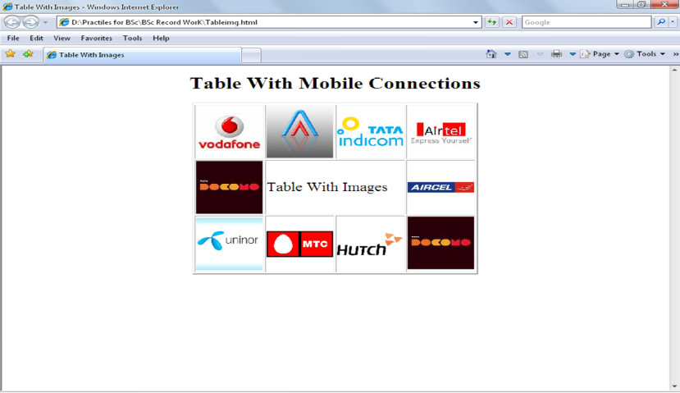

5. Create a web page with the following using HTML:
- To embed an image map in a web page
- To fix the hot spots
- Show all the related information when the hot spots are clicked.
6. Create a web page having frames as follows:
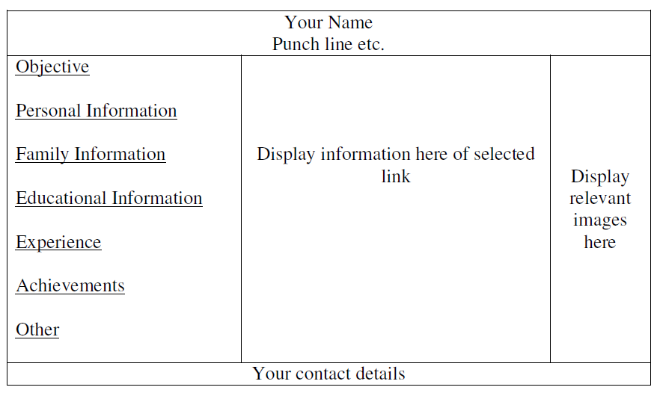

The frame which includes Objective, Personal Information ect. are the hyperlinks. Display the relevant information in the next frame on selecting the link. The colour scheme of hyper links should be as follows:
default – green
active – red
visited – blue

The information should be well formatted. Follow the instructions mentioned in the above format.

7. Demonstrate the use of <IFRAME> tag using suitable example.
8. Write a HTML code for the following snapshot.

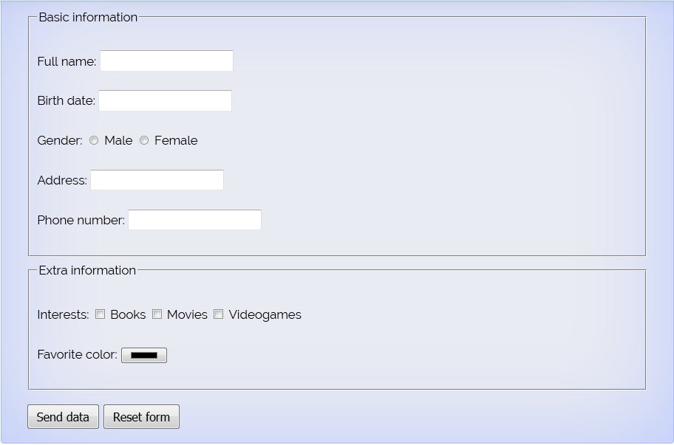

9. Create a web page of customer profile for data entry of customer’s in a Hotel, The profile should include Name, Address, Age, gender, Room Type (A/C, Non-A/C or Deluxe), Type of payment (Cash, Credit/Debit Card or Coupons).

10. Demonstrate the use of following HTML5 Tags:
- <Video>
- <Audio>
- <Header>
- <Footer>
- <Nav>
- <Embed>
- <Datalist>
- <Bdi>
- <Article>
- <Output>
- <Keygen>
Cascading Style Sheet
- Create a web page to show all hyperlinks with following specification:
- Default color is pink.
- Active color is blue
- Visited color is Green
- Hyperlink should be without underline.

- Create Box Shadow and text Shadow using CSS3.

- Create Rounded Corners using css3.

- Create a web page to show newspaper layout effects on contents given in web page (i.e. in multiple columns).

- Create a web page to show transition effect in such a way so that elements gradually change from one style to another style.

- Create a web page to show fixed background image (this image will not scroll with the rest of the page)

- Create a web page to position a background image and repeat the image horizontally or vertically.
- Create a web page to resize the background of web page.
9. Design a web page using CSS which includes the following:
- Use different font styles
- Set background image for both the page and single elements on page.
- Control the repetition of image with background-repeat property
- Define style for links as a:link, a:active, a:hover, a:visited
- Add customized cursors for links.
- Work with layers.
Snapshot

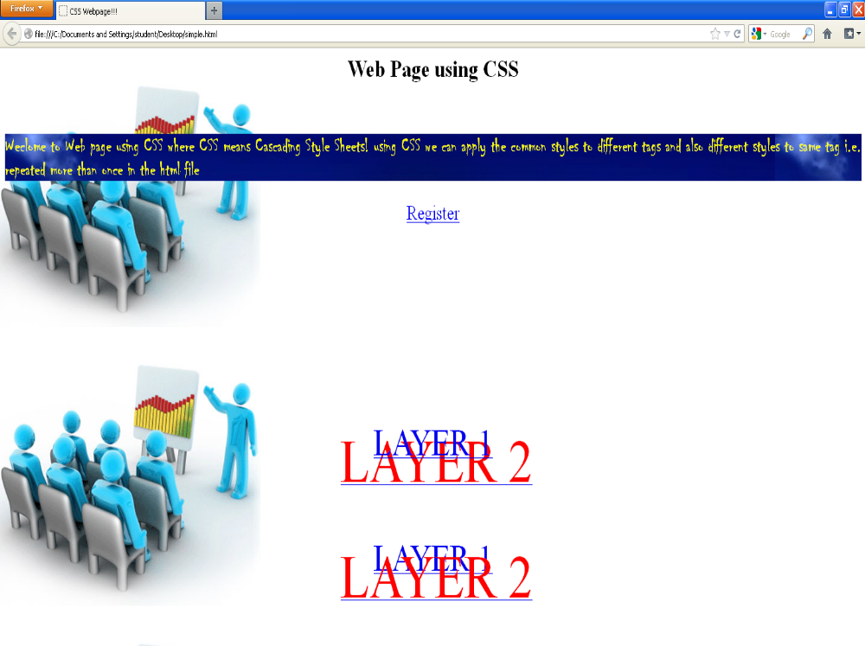

JavaScript

Checking Card Prefix and Length
Following tables outlines the major credit cards you might want to validate, along with their allowed prefixes and lengths.
Major Credit Cards, Their Prefixes, and Lengths
Card Type | Prefixes |  | Length
MasterCard | 51–55 |  | 16
Visa | 4 |  | 13,16
American Express | 34,37 |  | 15
Sample Well-Formed Credit Card Numbers
Card Type |  | Sample Number
MasterCard |  | 5500 0000 0000 0004
Visa |  | 4111 1111 1111 1111
American Express |  | 3400 0000 0000 009
1. Design a web page to validate credit card number according to the above specification.

- Design a web page to validate E-Mail-id and password.

- Store some country names and their capitals. Ask the user to select a country and its capital from given two lists. If the match is correct, display “Correct answer”, otherwise display error message and tell the correct answer.

- Design the simple Calculator.
- Design a web page that self modifying itself after every one minute.

- Write an code for web application, which accepts the birth date from the user in a textbox and display the day of the week in a message box on the click of a button.

- Write a script that inputs a telephone number as a string in the form (555)555-555. The script should use strings method split to extract the area code as token and the last four digits of the phone numbers as a token. Display the area code in one test field and the seven digit phone number in another text field.
- Create a web page that applies the invert filter to an image if the user moves the mouse over it.
- Write an HTML Page to scroll the text message from right to left at the status bar of browser window.

- Design a web page to perform survey on four different model of Maruti (Maruti -K10, Zen-Astelo, Wagnor, Maruti- SX4) owned by person living in four metro cities(Delhi, Mumbai, Chennai & Kolkatta). Display tabulated report like format given below:
 | Maruti-K10 | Zen-Astelo | Wagnor | Maruti-SX4
Delhi
Mumbai
Cheenai
Kolkatta

Calculate numbers of cars of different model in each metro city.

XML
1. Write an XML file which will display the Book information which includes the following:
- Title of the book
- Author Name
- ISBN number
- Publisher name
- Edition
- Price

Write a Document Type Definition (DTD) to validate the above XML file.

2. Display the above XML file as follows.
The contents should be displayed in a block. And the Author names information should be displayed in one color and should be capitalized and in bold. Use your own colors for remaining information. Use CSS for the above purpose.

PHP
1. Create a Login form having User-Id and Password fields. After submitting the form match the user-id and password with existing user-id and password. If user-id and password match a new welcome window should be appear.

3. Create a PHP page to display all the records from PERS table that contain Department Number(field name dno ) similar to that of given in list lstdno given in interface web browser screen.
4. Create a web page to maintain session using PHP.

5. Create a program to write & retrieve cookie.

6.

***

